API Request

🌐 What is an API Request
# Source: AI Source: Provided by: [Data Path: Persons Table -> ID Column: 1, Name_En Column: Motasem Essam] -> From: [ChatGPT] on [1/19/2026]
An API Request is a message sent by an API client to the server, asking it to perform an action on a resource via a specific endpoint.
👉 Think of it as the instruction you send to the API, telling it what to do and what data to use.

🔑 Components of an API Request
# Source: AI Source: Provided by: [Data Path: Persons Table -> ID Column: 1, Name_En Column: Motasem Essam] -> From: [ChatGPT] on [1/19/2026]
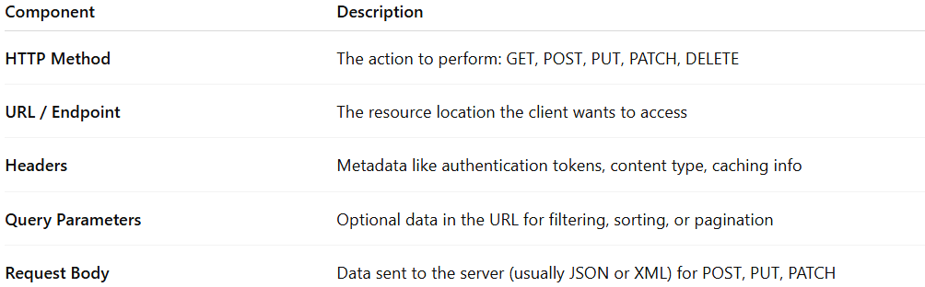
Component | Description
HTTP Method | The action to perform: GET, POST, PUT, PATCH, DELETE
URL / Endpoint | The resource location the client wants to access
Headers | Metadata like authentication tokens, content type, caching info
Query Parameters | Optional data in the URL for filtering, sorting, or pagination
Request Body | Data sent to the server (usually JSON or XML) for POST, PUT, PATCH

🧱 Example: Create User Request
# Source: AI Source: Provided by: [Data Path: Persons Table -> ID Column: 1, Name_En Column: Motasem Essam] -> From: [ChatGPT] on [1/19/2026]
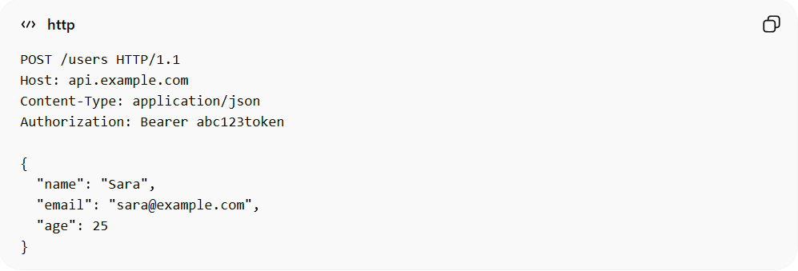
POST /users HTTP/1.1
Host: api.example.com
Content-Type: application/json
Authorization: Bearer abc123token

{
"name": "Sara",
"email": "sara@example.com",
"age": 25
}
Explanation:
- POST → HTTP method (create resource)
- /users → API endpoint for User resource
- Headers → specify content type & authentication
- Body → contains data for the new user

✅ Good Practices for API Requests
# Source: AI Source: Provided by: [Data Path: Persons Table -> ID Column: 1, Name_En Column: Motasem Essam] -> From: [ChatGPT] on [1/19/2026]
- Use the correct HTTP method for the intended action
- Include authentication/authorization headers if needed
- Keep request body minimal and relevant
- Use query parameters for filtering or sorting lists
- Follow RESTful naming conventions for endpoints

❌ Common Mistakes
# Source: AI Source: Provided by: [Data Path: Persons Table -> ID Column: 1, Name_En Column: Motasem Essam] -> From: [ChatGPT] on [1/19/2026]
- Sending GET requests with a body ❌
- Using POST to update existing resources ❌
- Forgetting required headers like Content-Type or authentication ❌
- Hardcoding endpoint URLs in multiple places ❌

💡 Summary
# Source: AI Source: Provided by: [Data Path: Persons Table -> ID Column: 1, Name_En Column: Motasem Essam] -> From: [ChatGPT] on [1/19/2026]
An API Request tells the server:
“I want to perform this action on this resource with this data.”

